Keys 7-8:
LISTENING
True or False? According to some superstitions, ……………….
1. You’ll be lucky if you smash an old mirror. __F__ 2. Servants who broke mirrors had got no money for their work. _T___ 3. Fresh fish can make a cat come nearer to you. _T___ 4. You should try to attract a black cat’s attention with a piece of fresh beefsteak. __F__ 5. If you want to see your friends again, go to a bridge together. _F___ 6. You can cure an unhealthy man with the help of an onion under the bed. __T__ 7. You can get rid of irritating guests by pushing them out of the room. __F__ 8. There should be twelve people sitting at a table for a meal. __T__

READING: 1b 2d 3c 4b
USE OF ENGLISH
1. Choose the right variant. 1a/ 2d/ 3d/ 4b/ 5c/ 6d/ 7c/ 8a/ 9/b 10c/
2. Complete the sentences with the appropriate forms of the words.
1. IMPROVEMENT 2 SPOONFULS 3. INTELLIGENCE 4. PERFORMANCE 5. COLLECTION 6. SADNESS 7. ACCURACY 8. ABILITY
3.
1 C  2 A  3 D  4 A | 5 D  6 B  7 C  8C | 9 A  10D  11 C  12 B | 13D  14 C  15 A  16D | 17 C  18 D
Система оценивания:
За каждый правильный ответ – 1 балл
Общая сумма баллов – 44 б

Texts for  Listening  7-8 |  | 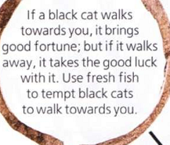 | 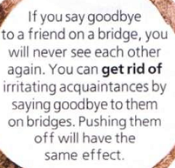
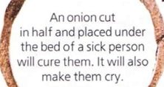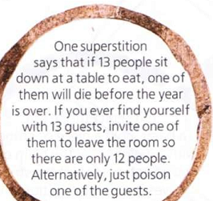

Texts for
Listening
7-8

